GRAPHIC OF THE WATER UTILITY
Mapping Climate Risks and Opportunities to Critical Water Utility Business Functions

  - Playbook for [INSERT WATER UTILITY NAME HERE] Tabletop Exercise

  - Date
Location

Table of Contents

Table of Contents 2
Handling Instructions 3
Overview 4
Common Terms and Definitions 5
General Information 7
Background 7
Exercise Goal 7
Exercise Objectives 7
Participant Roles and Responsibilities 7
Exercise Guidelines 8
Exercise Structure 8
Exercise Schedule 8
Situation Overview 10
Overarching State- or Regional-level Context 10
Water Customer Demographics 10
Planning for Change 10
Natural Systems Context 10
Built Infrastructure Context 10
Denver Water: Business Context 10
Module 1: Current Scenario 11
Module 1: Current Scenario 11
Module 1: Discussion Questions 12
Module 2: Future Scenario 1 14
Module 2: Future Scenario 1 14
Module 2: Discussion Questions 15
Module 3: Future Scenario 2 17
Module 3: Future Scenario 2 17
Module 3: Discussion Questions 18
Module 4: Potential Solutions 20
Module 4: Purpose 20
Module 4: Discussion Questions 21
Appendix 1: Participants & Roles 23
Appendix 2: Virtual TTX Agenda 24
Appendix 3: Climate 101 Presentation 25

Handling Instructions
The title of this document is the Mapping Climate Risk and Opportunities to Critical Water Utility Business Functions: Playbook for [INSERT WATER UTILITY NAME HERE] Tabletop Exercise.

This playbook reflects the information provided to the exercise planning team in advance of the tabletop exercise (TTX). This document is FOR [INSERT WATER UTILITY NAME HERE] PLANNING PURPOSES ONLY and should be handled as sensitive information not intended for any other use.

For more information on this exercise, please consult the following point of contact:

Internal Assessment Leader Name
Title
Phone: XXX-XXX-XXXX | Email:

Exercise Planning Team |  | Exercise Design Team (generally consultants)
Name | Title | Name | Title

Overview

Exercise Name | Mapping Climate Risks and Opportunities to Critical Water Utility Business Functions
Exercise Date
Scope
Objectives
Scenario
Participating Organizations
Point of Contact

Common Terms and Definitions

Adaptive Capacity | The ability of a person or system to adjust to a stressor, take advantage of new opportunities, or cope with change.
Business Function | A category of processes or operations that are performed routinely to carry out a part of the utility’s mission.
Cascading Impacts | Cascading Impacts occur as a direct or indirect result of an initial event, which, due to linkages between systems, results in major disruptions across an organization, supply chain, community, or region. The following two examples illustrate this concept:  - Flash flood electrical grid failure disrupts electricity traffic accidents hazardous materials spills local stream contamination neighborhoods evacuated.  - Higher temperatures more intense drought forest stress more severe wildfires poorer air quality increase in human respiratory issues.
Climate | The generally prevailing weather conditions of a region, throughout the year, averaged over a series of years.
Climate Adaptation | Actions taken to help limit risk and maximize opportunities associated with changing climate conditions or adjustments in natural or human systems in response to actual or expected climate stimuli or their effects, which moderates harm or exploits beneficial opportunities. Various types of adaptation can be distinguished, including anticipatory, autonomous, and planned adaptation.
Climate Mitigation | With respect to carbon emissions, measures to reduce the amount and speed of future climate change.
Climate Stressor | Events and trends related to weather, climate, and climate change that have an important, generally negative effect on exposed systems.
Community Resilience | Enabling the recognition, understanding, communication of, and planning for risk and empowering individuals and communities to make informed risk management decisions necessary to adapt to, withstand, and quickly recover from future incidents.
Exercise Planning Team | Utility staff who participate in the planning and design of the Tabletop Exercise and Playbook.
Governance | The structure of relationships and processes through which the objectives of the organization are set, progress against performance is monitored, and results are evaluated. Governance involves a set of relationships between the utility’s management, its Board of Commissioners, its shareholders, and other stakeholders.
Hazard | The potential occurrence of an event that may cause injury, illness, or death to humans, damage to assets or infrastructure, or adverse effects on ecosystems.
Hazard Mitigation | Any sustained action taken to reduce or eliminate the long-term risk to life and property from hazard events. It is an ongoing process that occurs before, during, and after disasters and serves to break the cycle of damage and repair in hazardous areas.
Impacts | Effects on natural and human systems due to extreme weather, climate events, and climate change.
Opportunity | The potential to derive positive outcomes from understanding and preparing for climate-related challenges, including resource efficiency and cost savings, development of new products and services, access to new markets, improved reputation of the utility, and building resilience across the utility and along its supply chain.
Risk | Threats to things of value (life, environment, etc.), evaluated by probability of hazardous event occurring multiplied by the effects event would have.
Resilience | The capacity to anticipate, plan, adapt, rapidly recover, and thrive in a changing climate.
Scenario | A scenario provides the storyline that drives an exercise to accomplish objectives. The scenario selected for an exercise should be informed by the actual threats and hazards faced by the exercise participants.
Tabletop Exercise (TTX) | A tabletop exercise (TTX) is typically held in an informal setting intended to generate discussion of various issues regarding a hypothetical, simulated emergency. TTXs can be used to enhance general awareness, validate plans and procedures, rehearse concepts, and/or assess the types of systems needed to guide the prevention of, protection from, mitigation of, response to, and recovery from a defined incident. Generally, TTXs are aimed at facilitating conceptual understanding, identifying strengths and areas for improvement, and/or achieving changes in attitudes.
Vulnerability | The propensity or predisposition of human and other systems to be adversely affected by climate change.
Weather | The actual state of the atmosphere with respect to wind, temperature, cloudiness, moisture, pressure, etc.

General Information

Background
An exercise is defined as “an instrument to train for, assess, practice, and improve performance in prevention, protection, mitigation, response, and recovery capabilities in a risk-free environment.” Exercises play a vital role in whole community preparedness and climate resilience. Preparedness means imagining the unimaginable, and considering the possibility of low-probability, high-consequence events as well as multiple, low-probability and high-probability events happening simultaneously. Resilience is the capacity to anticipate, plan adapt, and thrive in a changing climate.

Exercise Goal
The goal of this exercise is to [STATE THE EXERCISE GOAL HERE].

[INSERT WATER UTILITY NAME HERE] Key Business Functions:
- Natural Systems:
- Built Systems:
- Business Systems:

Exercise Objectives
- [INSERT EXERCISE OBJECTIVE 1 HERE]
- [INSERT EXERCISE OBJECTIVE 2 HERE]
- [INSERT EXERCISE OBJECTIVE 3 HERE]

Participant Roles and Responsibilities
The term participant encompasses many groups of people, not just those playing in the exercise portion of the event. Groups of participants involved in the exercise, and their respective roles and responsibilities, are as follows:
- Players. Players are personnel who have an active role in discussing or performing their regular roles and responsibilities during the exercise. Players should discuss or initiate actions in response to the simulated emergency based on expert knowledge of response procedures, as well as how they would perform their functions in their current role.
- Facilitators. Facilitators guide the overall exercise play and moderate discussions. They are responsible for ensuring that participant discussions remain focused on the objectives of the exercise during the Modules. They also provide additional information or resolve questions as required. Key Exercise Planning Team members also may assist with facilitation as subject matter experts (SMEs) during the exercise.
- Support Staff. Exercise support staff are members of the project consulting team who may perform administrative or logistical support tasks during the exercise. As designated note takers, support staff may ask clarifying questions for the purposes of accurate record keeping.
- Observers. Observers are outside groups that view the TTX exercise. They are stakeholders that would be impacted by the outcome of the results. They will be given an opportunity to participate at specific points of time but not through the whole exercise.

Exercise Guidelines
Participants should consider the following exercise ground rules to ensure the exercise runs smoothly and meets objectives in a reasonable amount of time:
- The exercise will be conducted in a no-fault learning environment, wherein systems and processes, not individuals, are evaluated.
- The exercise scenario is realistic and plausible, containing sufficient detail for an effective discussion.
- The goals and objectives of the exercise are consistent with discussion-based exercises focusing on operations and technical plans and procedures.
- There is no “hidden agenda,” nor any trick questions.
- The participants may need to balance exercise play with real-world emergencies. It is understood that real-world emergencies will take priority.
- Players are encouraged to participate openly – ask questions, share thoughts, offer forward-looking, problem-solving suggestions.
- Do not fight the scenario; it is designed to prompt discussion.
- This is to be a safe space to ask questions and bring up all ideas, even ‘silly’ ones. Outcomes will not be attributed to individuals.

Exercise Structure
This tabletop exercise will be scenario-based facilitated discussion split into X number of modules. Each module will begin with a scenario update, followed by a series of relevant discussion questions that will be posed to the exercise participants. The discussion will be driven by [INSERT WATER UTILITY NAME HERE] existing research, assessments, plans, policies, and procedures. The modules will be focused on the following:
- Module 1: Current Scenario
- Module 2: Future Scenario 1
- Module 3: Future Scenario 2
- Module 4: Potential Solutions

Exercise Schedule

Day 1 – DATE  (DAY) | Day 2 – DATE  (DAY) | Day 3 – DATE  (DAY)
10:00 – 11:00 AM  Welcome | Exercise Background  Guidelines and Structure | 9:30 – 10:00 AM  Summary of Day 1 Discussion | 1:00 – 1:30 PM  Summary of Days 1 & 2 Discussion
11:00 – 11:30 AM  Situation Overview | 10:00 AM – 12:00 PM  Module 2 | 1:30 – 3:30 PM  Module 4
11:30 AM – 12:30 PM  Lunch Break | 12:00 – 1:00 PM  Lunch Break | 3:30 – 4:00 PM  Summary and Next Steps
12:30 – 3:00 PM  Module 1 | 1:00 – 3:30 PM  Module 3 | 4:00 PM  Adjourn

Situation Overview

Overarching State- or Regional-level Context
Describe and provide graphics illustrating the current and projected (if available) economic state, GDP, critical sectors, and any other information relevant to set the scene of this state or region.

Water Customer Demographics
Describe and provide graphics illustrating the current and projected (if available) water customer demographics.

Planning for Change
Describe and provide graphics illustrating the current and planned changes the water utility is preparing for now.

Natural Systems Context
Describe and provide graphics illustrating the utility’s natural systems and any relevant context.

Built Infrastructure Context
Describe and provide graphics illustrating the utility’s built systems and any relevant context.

Denver Water: Business Context
Describe and provide graphics illustrating the utility’s business systems and any relevant context.

Module 1: Current Scenario

Module 1: Current Scenario
It is the year XXXX in [INSERT LOCATION JURISDICTION HERE]. Insert the scenario narrative here.

Module 1: Discussion Questions
Based on the information provided, participate in the discussion concerning the issues raised in this module. Identify any critical issues, decisions, requirements or questions that should be addressed.

- QUESTIONS TO BE ASKED VIA ZOOM CHAT FUNCTION
- What risks to your business function keep you up at night (by individual and business function)?
- What climate change drivers have been of most concern to your business function to date?

- UNDERLYING CONDITIONS
- What non-climate-related underlying vulnerabilities exist within your business function today?
  - Underlying conditions could include degrading infrastructure and interdependent systems that may have a common point of failure, aging workforce, lack of updated technology systems, diminished financial reserves, or competing priorities.
- What were your 2-3 most recent significant non-climate-related challenges (man-made or natural) within your business function?
- What non-climate-related risks (man-made or natural) are you preparing for into the future?
- Could climate change impact any of the non-climate-related risks?

- LESSONS AND INSIGHTS FROM PAST EVENTS
- Based on your experiences, what have been the lessons relative to risk management learned to date?
- What lessons did you learn during COVID-19?
- What were your experiences and lessons learned when simultaneous events occurred in the past? (e.g., 2002 drought –> fire –> flood events)
- What do you wish you had in place now that you don’t currently have to prepare for the future?

- CLIMATE CHANGE DRIVERS, RISKS, AND IMPACTS
- Over the last 20 years, which impact(s) (acute and chronic) seem to have the most direct impact on your business function?
- What is the impact to assets and systems from floods, fires, extreme heat, extreme cold, or other climate drivers? Are there any constraints in the capability to respond?
- What new risks or opportunities emerged over the last 5-10 years that were not anticipated or planned for prior to 2020?
- What are the cascading impacts to your business function from these climate drivers?
- Are these cascading impacts affecting your operations, staffing, communication, ability to prepare and respond?
- In the event of an acute climate-related disaster, what plans do you have for maintaining critical work (e.g., communications, food, shelter and equipment for utility and mutual aid workers)? How long will these logistical support services or supplies last?

- CLIMATE RISK MANAGEMENT AND ADAPTATION PLANNING
- How do you currently keep employees safe and healthy in extreme weather conditions, and how can you ensure continued health and safety as these conditions occur more frequently?
- What actions is your business function taking now to manage, mitigate, and adapt to the climate-related risks your business functions face today (both acute and chronic)?
- In terms of assets and systems to protect, how do you currently determine which are most important to prioritize and protect?
- What fire proofing measures have you implemented for facilities and properties owned by Denver Water?
- Have you experienced any impacts from climate-related events (acute or chronic) on your business functions financial performance?
- How are you managing financial and supply chain risks associated with water quality, water resource and availability, and/or purchasing goods and services?
- What opportunities do you see for enhancing resilience going forward?

- CLIMATE CHANGE DATA, INFORMATION, TOOLS, AND PLANS
- What climate data, information, or tools do you currently use to help inform decisions related to your business function?
- What data, information, or tools don’t you have currently that you think would be useful for your business function?
- What climate-related data or information, do you collector tools have you generated?
- What climate-related plans have you used to help inform decisions related to your business function?

- COORDINATION WITH OTHER BUSINESS FUNCTIONS
- What do you need to know about the other utility business functions that would help you to manage climate-related risks and enhance resilience?
- What questions, climate-related or other, do you have for the other business functions in the room?

Module 2: Future Scenario 1

Module 2: Future Scenario 1
We are in a warmer world now. Describe the future scenario narrative here.

Table 3: Module 2 Summary Conditions
Climate Impact | Observed Change

Module 2: Discussion Questions
Based on the information provided, participate in the discussion concerning the issues raised in this module. Identify any critical issues, decisions, requirements or questions that should be addressed.

- UNDERLYING CONDITIONS
- What existing underlying conditions and vulnerabilities might be exacerbated by this scenario?
- What new underlying conditions and vulnerabilities might exist within your business function in this scenario (e.g., operations, workforce, finance, resources, technology)?
- How will climate change impact these new vulnerabilities?

- CLIMATE CHANGE DRIVERS, RISKS, AND IMPACTS
- What climate change drivers might be of most concern to your business function in this scenario?
  - How does alternating between heatwaves and fires year-round impact your business function?
  - How does a wet spring and/or wet summer impact your business function?
  - What about a dry spring and/or dry summer?
- How will these conditions impact existing or new natural, built, and business infrastructure?
- How will these conditions impact your operations, staffing, communication, ability to prepare and respond in this scenario?
  - How do you currently keep employees safe and healthy in extreme weather conditions, and how can be ensure continued health and safety as these conditions become regular?
- What cascading impacts might keep you up at night in this scenario (by individual and business function)?
- What will be the impact on financial performance within your business function?
- Do funds currently exist to adapt to this type of future, or do funds need to be allocated/reserved for hazard mitigation, climate adaptation, or resilience?

- CLIMATE RISK MANAGEMENT AND ADAPTATION PLANNING
- Are there current plans or processes that your business function has now that address the impacts discussed as a result of this scenario?
  - What redundancies do you need if there are multiple, simultaneous fires throughout the collection system in this scenario?
- What actions will your business function need to take in this scenario to manage, mitigate, and adapt to the climate impacts expected in this scenario (both acute and chronic)?
- What might be the impact on financial performance within your business function in this scenario?
- If there are limited financial resources due to the response to previous climate-related disasters, how can your business function prioritize funding?
- How do you currently keep employees safe and healthy in extreme weather conditions, and how can be ensure continued health and safety as these conditions become regular?
- Are there new technologies that will become available for water resource management that should be considered in budgeting and future planning?
- Are there behavioral changes that need to be taken into consideration to minimize the impacts to your business function in this scenario?
- What actions is your business function taking, or should be taken, to mitigate greenhouse gases.
- CLIMATE CHANGE DATA, INFORMATION, AND PLANS
- What climate data, information, assessments, or plans do you need to help inform decisions related to your business function in this scenario?

- COORDINATION WITH OTHER BUSINESS FUNCTIONS
- Is there capacity within your current teams to manage the challenges outlined in this scenario?
- Is there capacity or services you require outside of your business function but in another business function that you should collaborate or partner with to further assess and manage the challenges outlined in this scenario?
- What do you need to know about the other utility business functions that would help you to identify signposts/threshold conditions, manage climate-related risks, and enhance resilience in this scenario?

- STAKEHOLDER COLLABORATION, COMMUNICATION, AND OUTREACH
- Are there partnerships your business function or Denver Water might want to more broadly explore to help address the gaps in capacity to manage these challenges?
- What external stakeholders do you need to collaborate with to advance risk assessment, management, adaptation, and resilience at various levels and scales (business function, water utility, city, county, state, national)?

Module 3: Future Scenario 2

Module 3: Future Scenario 2
We have entered a hotter world now. Describe the future scenario narrative here.

Table 4: Module 3 Summary Conditions
Climate Impact | Observed Change

Module 3: Discussion Questions
Based on the information provided, participate in the discussion concerning the issues raised in this module. Identify any critical issues, decisions, requirements or questions that should be addressed.

- UNDERLYING CONDITIONS
- What existing underlying conditions and vulnerabilities might be exacerbated by this scenario?
- What new underlying conditions and vulnerabilities might exist within your business function in this scenario (e.g., operations, workforce, finance, resources, technology)?
- How will climate change impact these new vulnerabilities?

- CLIMATE CHANGE DRIVERS, RISKS, AND IMPACTS
- What climate change drivers might be of most concern to your business function in this scenario?
  - How does alternating between floods and fires year-round impact your business function in this scenario?
  - How does a wet spring and/or wet summer impact your business function?
  - What about a dry spring and/or dry summer?
- How might these conditions impact existing or new natural, built, and business infrastructure?
- How might these conditions impact your operations, staffing, communication, ability to prepare and respond in this scenario?
  - How do you currently keep employees safe and healthy in extreme weather conditions, and how can be ensure continued health and safety as these conditions become regular?
- What cascading impacts might keep you up at night in this scenario (by individual and business function)?
- What might be the impact on financial performance within your business function?
- Do funds currently exist to adapt to this type of future, or do funds need to be allocated/reserved for hazard mitigation, climate adaptation, or resilience?

- CLIMATE RISK MANAGEMENT AND ADAPTATION PLANNING
- Are there current plans or processes that your business function has now that address some of the challenges laid out in this scenario?
  - What redundancies do you need if there are multiple, simultaneous fires throughout the collection system?
- What actions will your business function need to take in this scenario to manage, mitigate, and adapt to the climate impacts expected in this scenario (both acute and chronic)?
- What might be the impact on financial performance within your business function in this scenario?
- If there are limited financial resources due to the response to previous climate events, how should you prioritize funding?
- Are there new technologies that have become available for water resource management that should be considered in budgeting and future planning?
- Are there behavioral changes that need to be taken into consideration to minimize the impacts to your business function in this scenario?
- What actions is your business function taking, or should be taken, to mitigate greenhouse gases.

- CLIMATE CHANGE DATA, INFORMATION, AND PLANS
- What climate data, information, assessments, or plans do you need to help inform decisions related to your business function in this scenario?

- COORDINATION WITH OTHER BUSINESS FUNCTIONS
- Is there capacity within your current teams to manage the challenges outlined in this scenario?
- Is there capacity or services you require outside of your business function but in another business function that you should collaborate or partner with to further assess and manage the challenges outlined in this scenario?
- What do you need to know about the other utility business functions that would help you to identify signposts/threshold conditions, manage climate-related risks, and enhance resilience in this scenario?

- STAKEHOLDER COLLABORATION, COMMUNICATION, AND OUTREACH
- Are there partnerships your business function or Denver Water might want to more broadly explore to help address the gaps in capacity to manage these challenges?
- What external stakeholders do you need to collaborate with to advance risk assessment, management, adaptation, and resilience at various levels and scales (business function, water utility, city, county, state, national)?

Module 4: Potential Solutions

Module 4: Purpose
During this module, players will focus on identifying and prioritizing potential solutions related to risk management, adaptation actions, and mainstreaming resilience across the business functions and whole utility. Module 4 will begin with reflection and discussion of solutions identified in Modules 1, 2, and 3, and then transition to identify additional solutions. The players will consider pros and cons of the various solutions. Some solutions will be competitive – in terms of conflicting priorities or competing for resources – while others will be additive or complementary across the business functions. All solutions will be documented, and synergies will be identified, where applicable.

Once an exhaustive list of solutions has been identified, the players will discuss how to prioritize the solutions, with the anticipation of identifying 5-10 key solutions that the EPT may present to the Board of Commissioners as staff recommended ways [INSERT WATER UTILITY NAME HERE] can mainstream adaptation and resilience utility-wide.

Module 4: Discussion Questions
Based on the information provided, participate in the discussion concerning the issues raised in this module. Identify any critical issues, decisions, requirements or questions that should be addressed.

- TOP RISKS TO NATURAL, BUILT, AND BUSINESS SYSTEMS (SUMMARIZE)
- What are the top climate risks to these natural, built, and business systems, and operational functions, including the ripple effects to other sections and divisions within the organization?
- How do we prioritize the most urgent risks that can be mitigated through proactive investments and commit to developing and investing in adaptation solutions?
- What risks cannot be mitigated and how do we commit to developing (emergency and systemic) preparedness and response protocols to enhance risk management and resilience?
- What are the critical signposts or early warnings needed to identify threshold conditions and/or determine the potential for risks to emerge?

- SOLUTIONS NEEDED TODAY (2020), IN A WARMER SCENARIO, AND IN A HOTTER SCENARIO FUTURE
- What natural, built, and business solutions or opportunities should we advance to prepare for and adapt to these scenarios?
  - Climate mitigation
  - Hazard mitigation
  - Climate adaptation
  - Monitoring (including key threshold/signpost indicators)
- What are the costs and benefits (pros and cons) of these solutions?
- When should these solutions be implemented? Identify the dependency of solutions (mid-term goals may depend on the completion of short-term goals) and relationship to signposts.
- What do we need to start to get these solutions implemented (e.g., change current plans or create a new plan, practices, decision processes, or policies)?
- What solutions are robust and work to meet the needs of multiple functions and other co-benefits?
- How do we prioritize these solutions or align them with current priorities?
- What internal and external partnerships do we need to form to share the risk and could contribute in proactive investments in solutions?
- What actions can you undertake to incorporate climate change and the results of this TTX into current and future plans, practices, decisions, and financial investments?
- How should you monitor and track the actions taken to implement these solutions?
- What resources and funding are needed to implement these actions?
- How should resilience be mainstreamed into your business functions?
- How can/should you integrate climate change into internal messaging? Into external messaging?

- BARRIERS TO ACTION
- What barriers and opportunities exist to advance the solutions needed? For example, new design standards, partnerships that need to be built, policy changes, new funding sources or mechanisms, staff training, collective action, R&D (science, technology), strategic hires, staffing needs (addressing aging workforce).
- What hard discussions and decisions need to be collaboratively discussed now as it relates to implementing these solutions?
- What climate risks and impacts might you not be able to manage or minimize?

- NEXT STEPS
- How should we communicate about the outcomes of this TTX?
- What business functions would you recommend be assessed next (e.g. human resources, emergency response planning, engineering)?
- What is your assessment (evaluation) of the quality of the exercises? How could this exercise could have been planned for and conducted better?
- What three things will you bring to your work and/or team, or take action on after participating in the exercise?
- What was the most notable thing you learned from another business function during this TTX?

Appendix 1: Participants & Roles
Name | Organization | Role

Bold indicates members of the Exercise Planning Team.
Italics indicates members of the Exercise Design Team.

Appendix 2: Virtual TTX Agenda

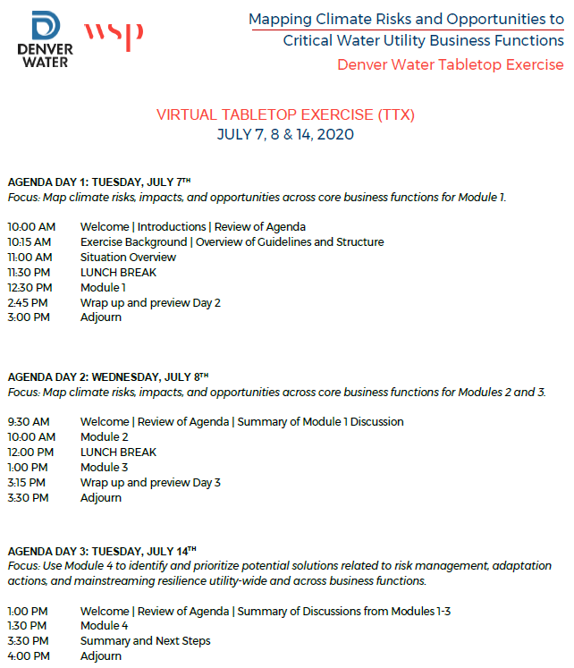

Appendix 3: Climate 101 Presentation

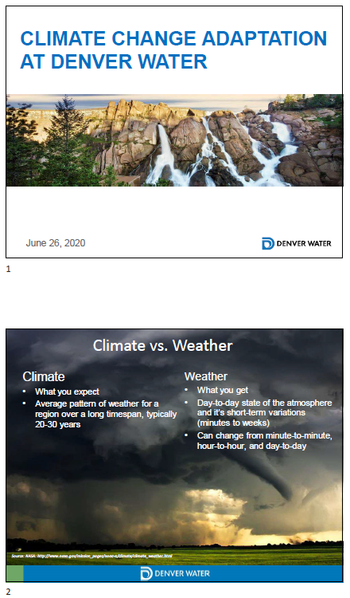
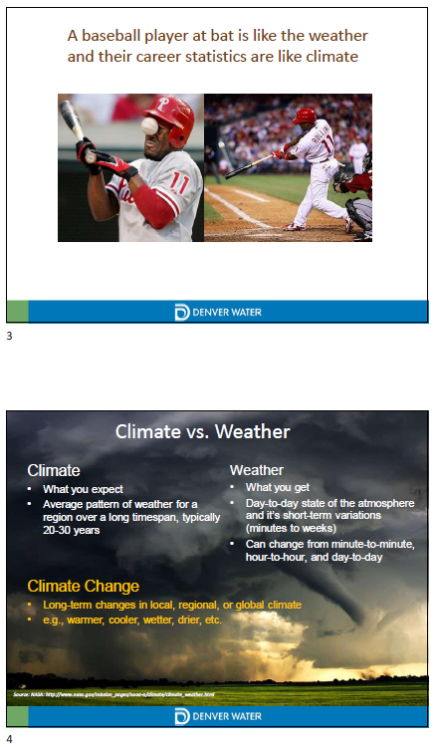
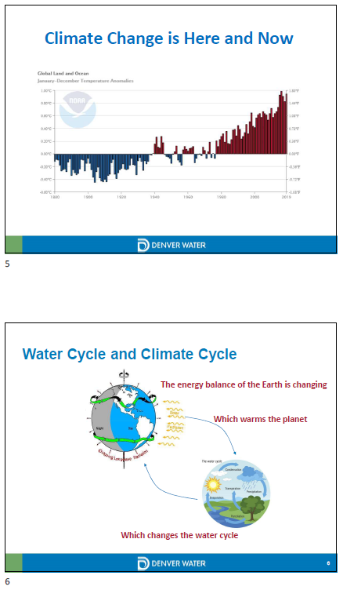
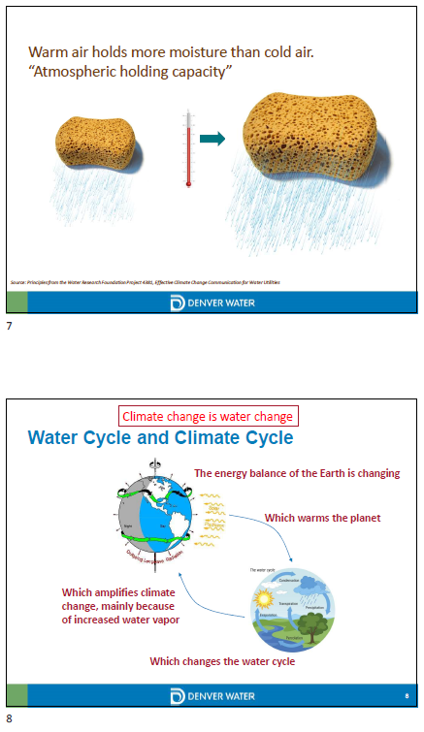
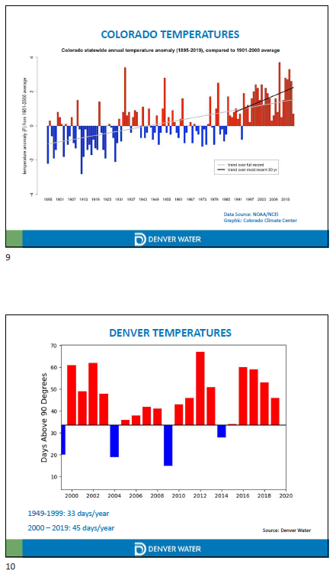
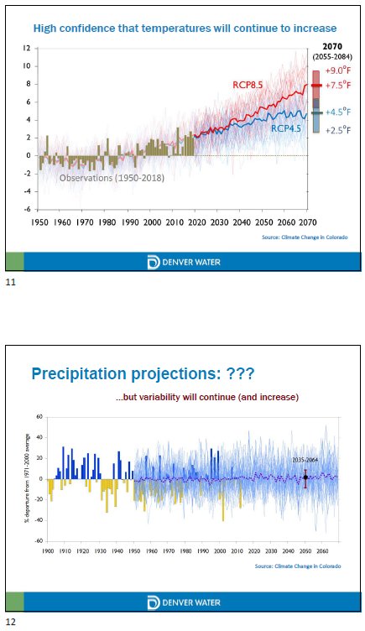
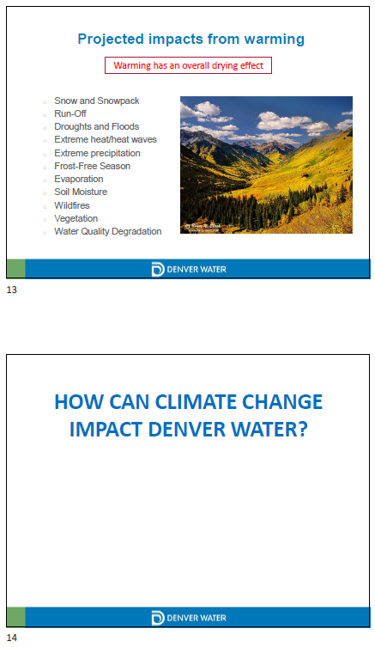
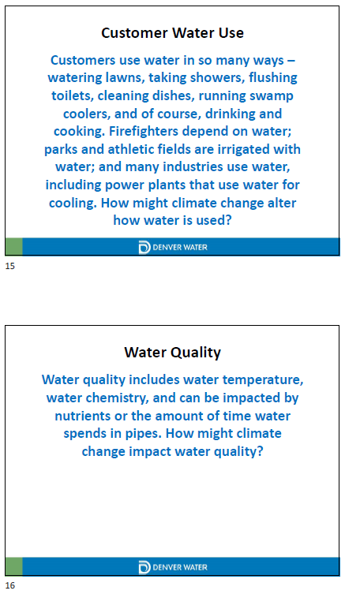
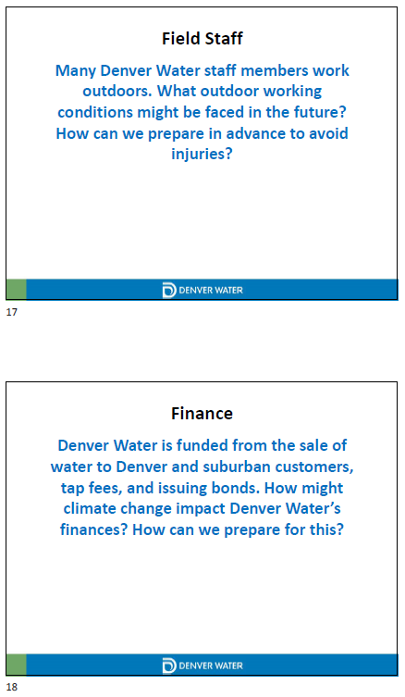
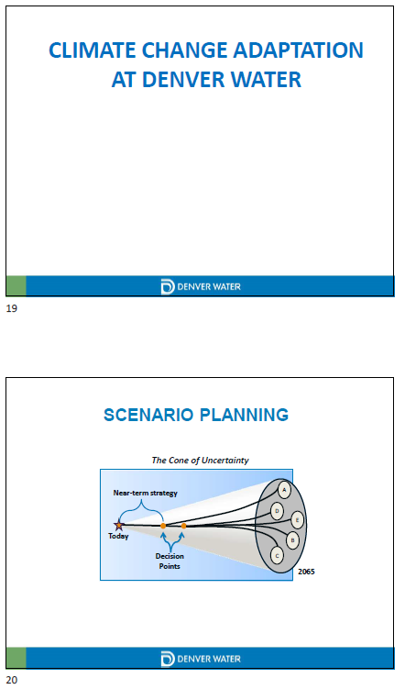
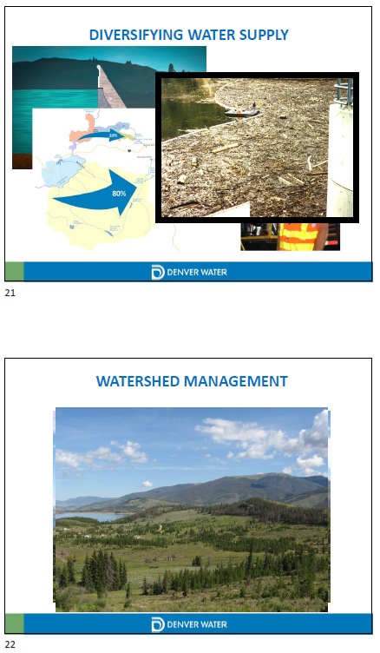
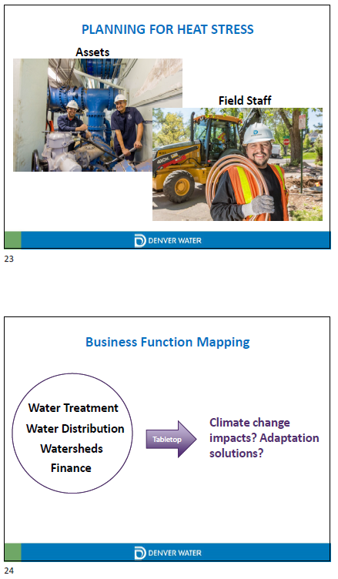

Ibid, 16.
Mapping Climate Exposure and Climate Information Needs to Water Utility Business Functions, 131.
Mapping Climate Exposure and Climate Information Needs to Water Utility Business Functions, 131.
California Adaptation Form Pre-Forum Drought Exercise: Situation Manual, 17.
Wasley, E., K. Jacobs, and J. Weiss. Mapping Climate Exposure and Climate Information Needs to Water Utility Business Functions. Project 4729a. The Water Research Foundation, 2020. https://www.wucaonline.org/assets/pdf/project-4729B-guidebook.pdf, 131.
Wasley, E. California Adaptation Form Pre-Forum Drought Exercise: Situation Manual. Cadmus, 2016. http://cdn2.hubspot.net/hubfs/472557/Situation_Manual_CAF_Drought_Exercise_0902_Cadmus.pdf?__hssc=121325015.1.1592530318019&__hstc=121325015.88669e8617d1e4e944ffa7fe08790257.1591140862832.1591922957115.1592530318019.3&__hsfp=204825244&hsCtaTracking=a4ffba1d-d34e-446c-8b79-4ef3daea37c1%7C85783f6c-35d3-4941-a295-e7daaa33d659, 16.
Task Force on Climate-Related Financial Disclosures. Implementing the Recommendations of the TCFD. 2020. https://www.fsb-tcfd.org/wp-content/uploads/2017/06/FINAL-TCFD-Annex-062817.pdf, 78.
California Adaptation Form Pre-Forum Drought Exercise: Situation Manual, 17.
California Adaptation Form Pre-Forum Drought Exercise: Situation Manual, 17.
Mapping Climate Exposure and Climate Information Needs to Water Utility Business Functions, 131.
California Adaptation Form Pre-Forum Drought Exercise: Situation Manual, 18.
Ibid, 131.
California Adaptation Form Pre-Forum Drought Exercise: Situation Manual, 18.
California Adaptation Form Pre-Forum Drought Exercise: Situation Manual, 19.
Ibid, 19.
Ibid, 19.
“Glossary,” FEMA Emergency Management Institute, accessed June 30, 2020, https://training.fema.gov/is/course/glossary.aspx.

